**Homework 2: Decision Tree Learning for Classification**

**（03/24 9:50 之前提交）**

**1Introduction**

Decision tree induction is one of the simplest and yet most successful learning algorithms. A decision tree (DT) consists of internal and external nodes and theinterconnections between nodes are called branches of the tree. An internal nodeis a decision-making unit to decide which child nodes to visit next depending ondifferent possible values of associated variables. In contrast, an external node alsoknown as a leaf node, is the terminated node of a branch. It has no child nodesand is associated with a class label that describes the given data. A decision treeis a set of rules in a tree structure, each branch of which can be interpreted as adecision rule associated with nodes visited along this branch.

**2 Principle and Theory**

Decision trees classify instances by sorting them down the tree from root to leaf nodes. This tree-structured classifier partitions the input space of the data set recursively into mutually exclusive spaces. Following this structure, each training data is identified as belonging to a certain subspace, which is assigned a label, a value, or an action to characterize its data points. The decision tree mechanism has good transparency in that we can follow a tree structure easily in order to explain how a decision is made. Thus interpretability is enhanced when we clarify the conditional rules characterizing the tree.

Entropy of a random variable is the average amount of information generated by observing its value. Consider the random experiment of tossing a coin with probability of heads equal to 0.9, so that P(Head) = 0.9 and P(Tail) = 0.1. This provides more information than the case where P(Head) = 0.5 and P(Tail) = 0.5. Entropy is used to evaluate randomness in physics, where a large entropy value indicates that the process is very random. The decision tree is guided heuristically according to the information content of each attribute. Entropy is used to evaluate the information of each attribute; as a means of classification. Suppose we have *m* classes, for a particular attribute, we denoted it by pi by the proportion of data which belongs to class *Ci*where*i = 1, 2, … m.*

The entropy of this attribute is then:

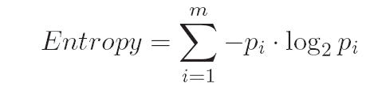

We can also say that entropy is a measurement of the impurity in a collection of training examples: larger the entropy, the more impure the data is. Based on entropy, Information Gain (IG) is used to measure the effectiveness of an attribute as a means of discriminating between classes.

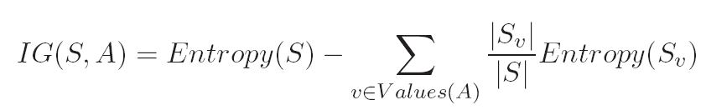

where all examples *S* is divided into several groups (i.e.*Sv* for *v ∈ Values(A)*) according to the value of *A*. It is simply the expected reduction of entropy caused by partitioning the examples according to this attribute.

**3 Objective**

The goals of the experiment are as follows:

(1) To understand why we use entropy-based measure for constructing a decision tree.

(2) To understand how Information Gain is used to select attributes in the process of building a decision tree.

(3) To understand the equivalence of a decsion tree to a set of rules.

(4) To understand why we need to prune the tree sometimes and how can we prune? Based on what mesure we prune a decsion tree.

(5) To understand the concept of Soft Decsion Treees and why they are imporant extensions to classical decision trees.

**4 Contents and Procedure**

**Stage 1:**

1. According to the above principle and theory in section 3.2, implement the code to calculate the information entropy of each attribute.
2. Select the most informative attribute from a given classification problem (e.g., we will be given the Iris Dataset from the UCI Machine Learning Repository)
3. Find an appropriate data structure to represent a decion tree. Building the tree from the root to leaves based on the principal discussed in section 3.2 by using Information Gain guided heuritics.

**Stage 2:**

1. Now consider the case of with continuous attributes or mixed attributes (with both continuous and discrete attributes), how can we deal with the decision trees? Can you propose some approaches to do discretization?
2. Is there a tradeoff between the size of the tree and the model accuracy? Is there existing an optimal tree in both compactness and performance?
3. For one data element, the classical decsion tree gives a hard bounday to decide which branch to follow, can you propose a “soft approach” to increase the robustness of the decision tree?
4. Compare to the Naïve Bayes, what are the advantages and disvantages of the decision tree learning?

**Stage 3：**

Explore the questions in the previous section and design experiments to answer these questions. Complete and submit an experiment report about all experiment results with comparative analysis and a summary of experiences about this experiment study.